**Edit History**

2015/09/17

David Preiss – Created

SBG199: Manual +2 Axis Accessory (004588)

Setup and Use

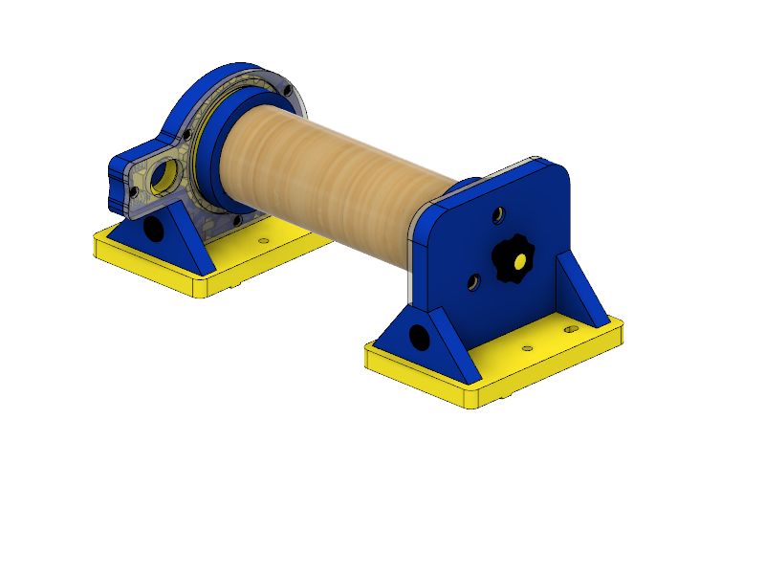

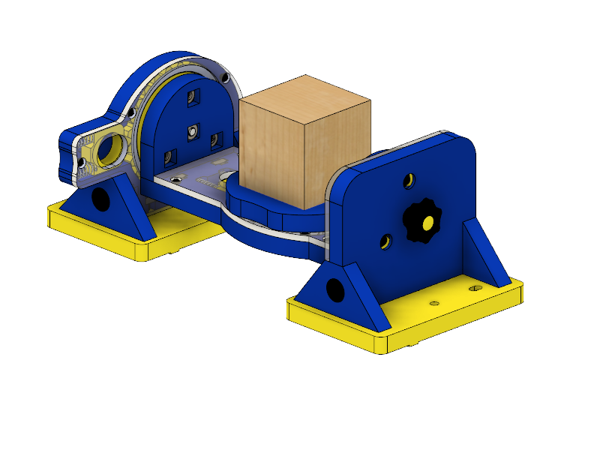

Contents

Introduction 2

Set Up 3

4 and 5 Axis Configurations: 3

Mounting to the Accessory Base: 5

Material Selection and Setup 7

4 Axis: 7

5 Axis: 8

Zeroing 9

Zeroing in the X: 9

Zeroing in the Y 10

Zeroing in the Z: 11

Desktop and Max Use 12

Software Use: 13

Aspire Parameters: 13

Aspire 5 Axis Rotation: 14

Introduction

The Manual +2 Axis Accessory is a jig designed to manually rotate parts beneath a Handibot, allowing for multi-sided machining which expands the functionality of a standard 3 axis tool to 4 and 5 axis. The jig can be configured to act as a rotary indexer (+1), where the Handibot will function similarly to a lathe, as well as a configuration that supports 5 axis machining by adding a trunnion rotary axis (+2). All non-metal materials machinable with a Handibot are machinable with the Manual +2 Axis Accessory. The accessory can be used with a HandiBot and Accessory Base, as well as a Desktop, Desktop Max, or any tool with requisite travel. It is possible to use this accessory in both 4 and 5 axis with existing Aspire and Fusion 360 software.

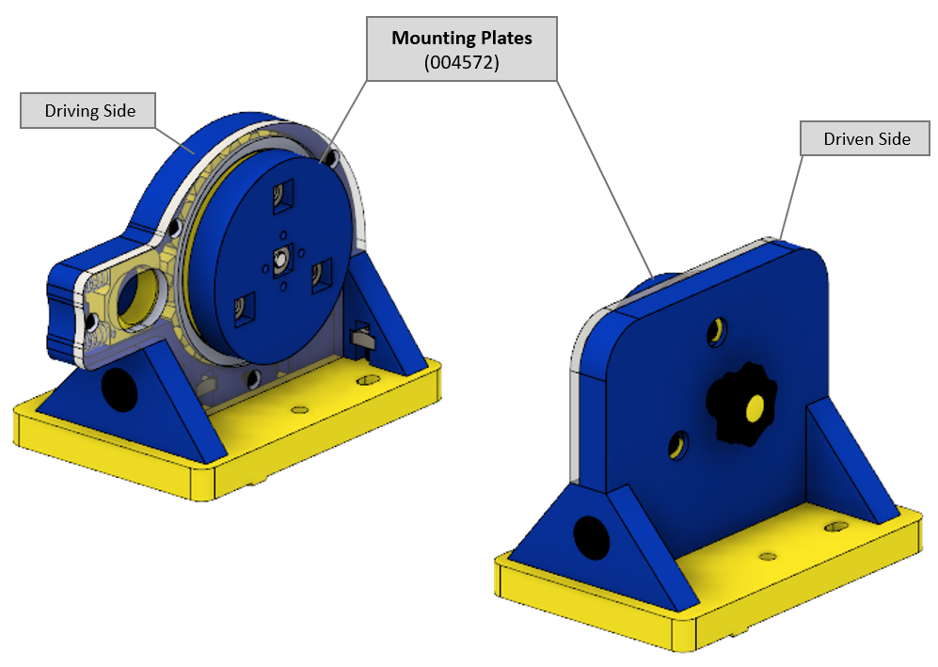

Figure 1: 4 Axis Configuration

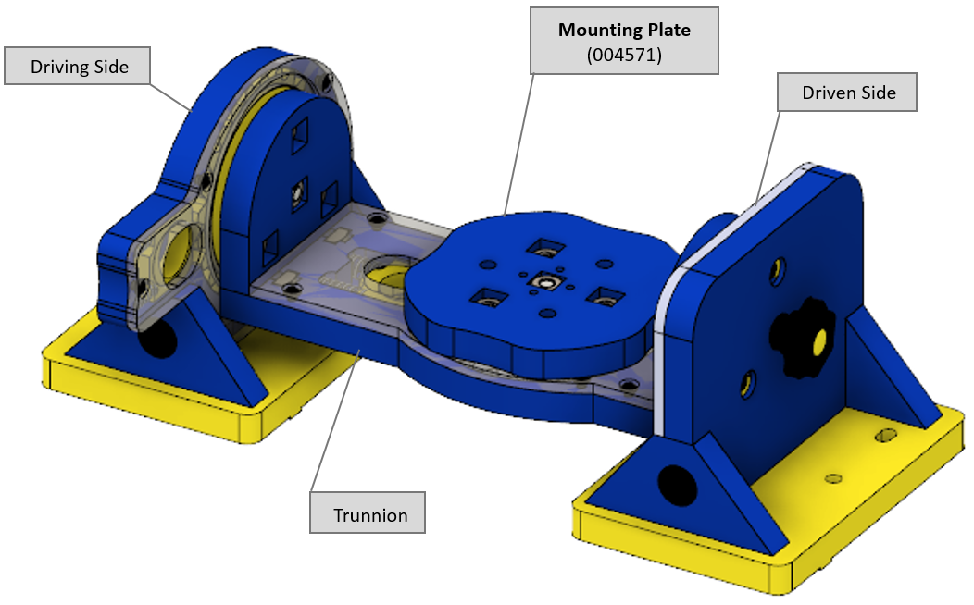

Figure 2: 5 Axis Configuration

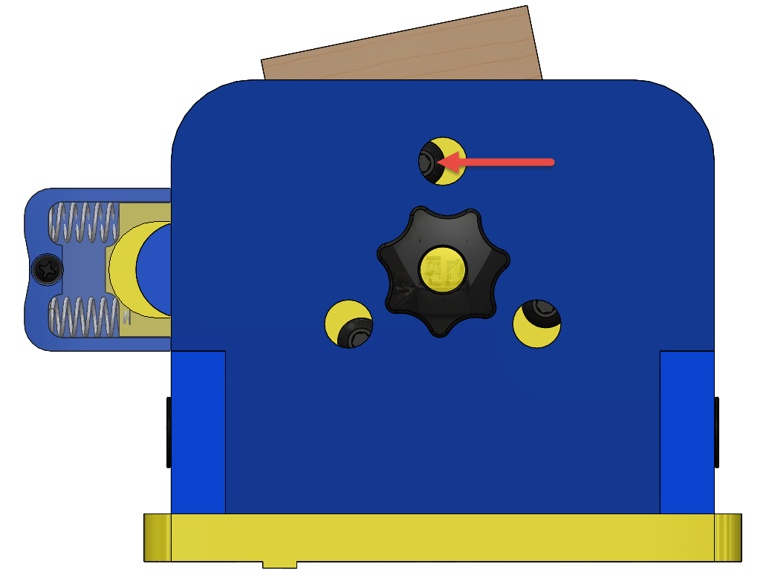Set Up

To become familiar with the terminology and part numbers used throughout this document, it is recommended that users reference the accessory’s DIY assembly guide: http://shopbot.dozuki.com/c/DIY_Build.

4 and 5 Axis Configurations:

The Manual +2 Axis Accessory will come shipped in its 5 axis configuration. To configure for 4 axis:

1. Remove two thumb screws from rear of the driving and driven sides of the accessory.

Figure

1. Remove 6 bolts from rear of the driving and driven sides using a 4mm hex key. The trunnion must be rotated such that the bolts are exposed through their respective access holes (Figure 3).

The trunnion will then be released from the driving and driven sides of the tool. Note that the mounting plate on the trunnion is attached identically (Figure 4).

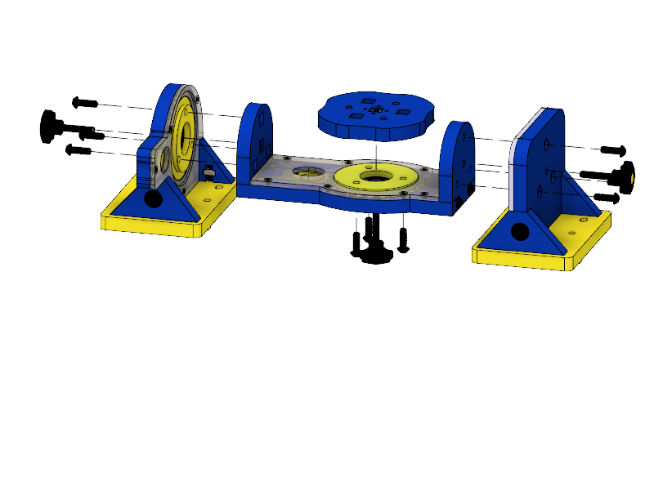

**Thumb Screw** (004564)

**Bolts**

Figure

Use the same 6 bolts as well as two thumb screws to attach the two 4 Axis Mounting Plates (004572), in place of the trunnion (Figure 5). These plates are shipped unattached.

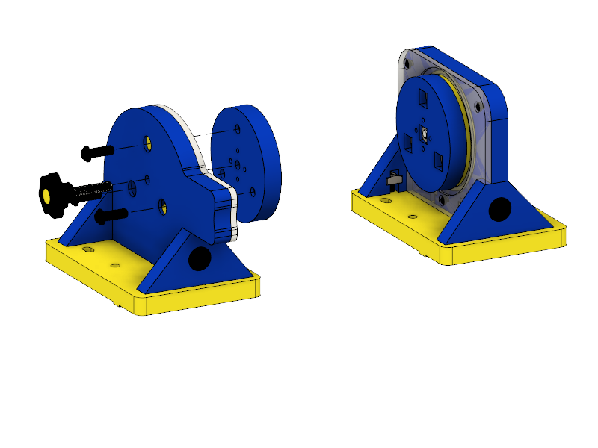

Figure

To rotate either of the accessory’s axis:

1. Loosen thumb screw of the axes to be rotated (Figure 4).
2. Squeeze and hold the yellow spring-loaded trigger corresponding to the axes to to be turned (Figure 6). This will disengage the pin from the gear’s teeth and allow the axis to be spun by hand.
3. Once in the desired position, release trigger and re-tighten the coresponding thumb screw until hand tight.

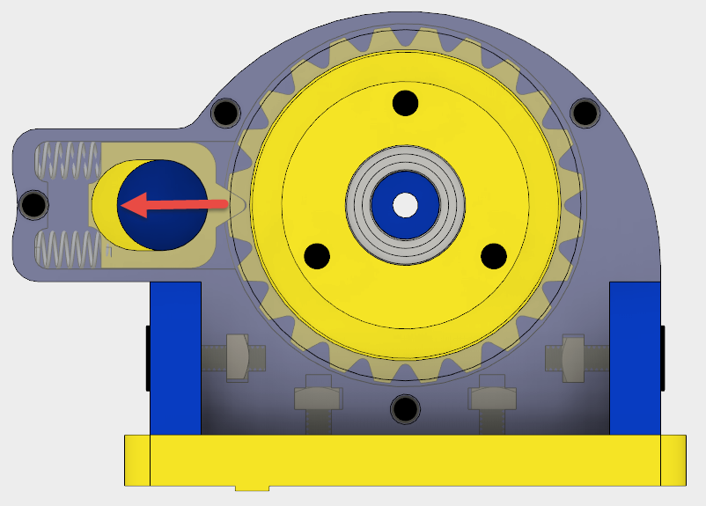 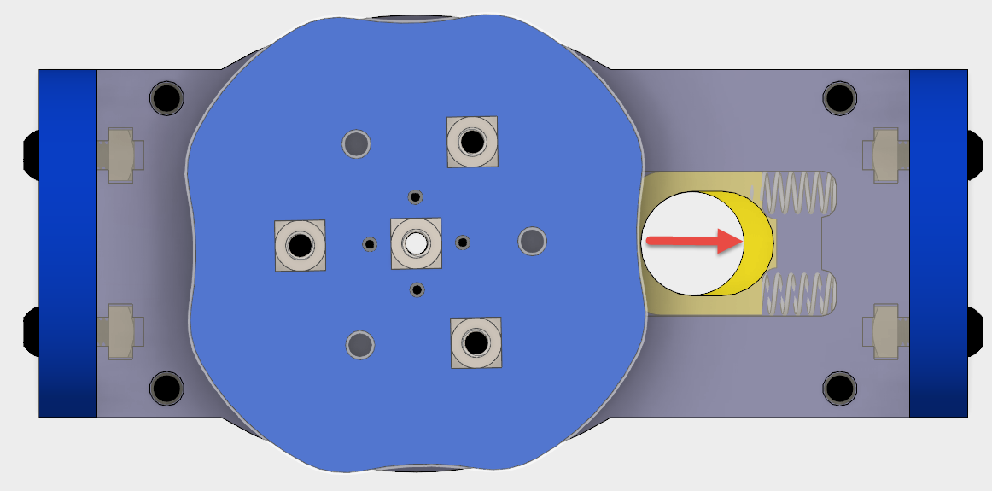

Figure

Mounting to the Accessory Base:

The accessory can be mounted to the Handibot accessory base using the set of 8 bolts (002135) and 8 weld nuts (003461) provided. The process is identical for both 4 and 5 axis configurations. In order to mount the accessory to the base tray:

1. Press or screw the 8 bolts into their respective holes in the yellow base plates (Figure 7).
2. Screw on the 8 weld nuts with flange up, approxmately half a turn, and align them lengthwise with the length of the accessory.
3. Slide the weld nuts into the grooves on the accessoy base tray, making sure that all the nuts are aligned and that there is a groove to accept the guide rails on the yellow base plates (Figure 8).

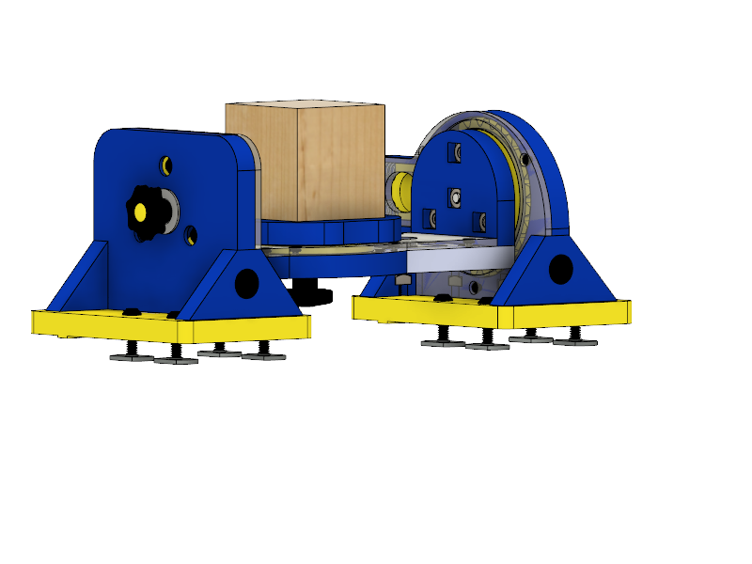

Figure

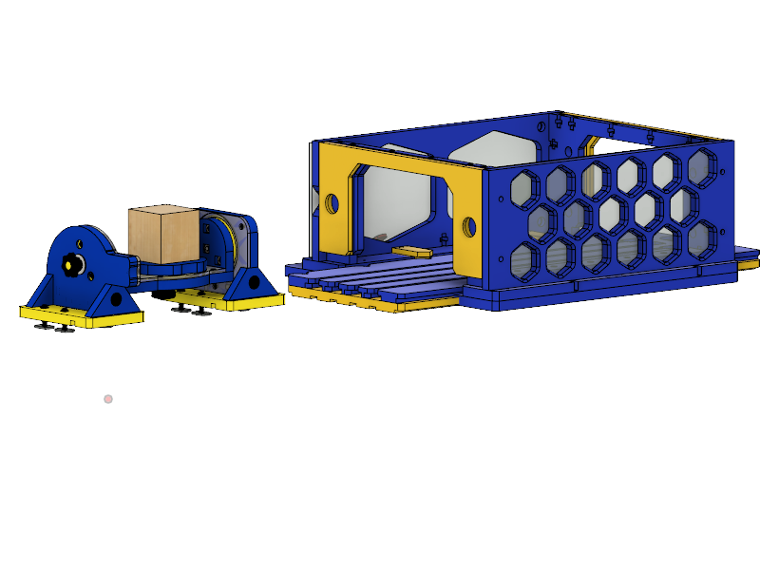

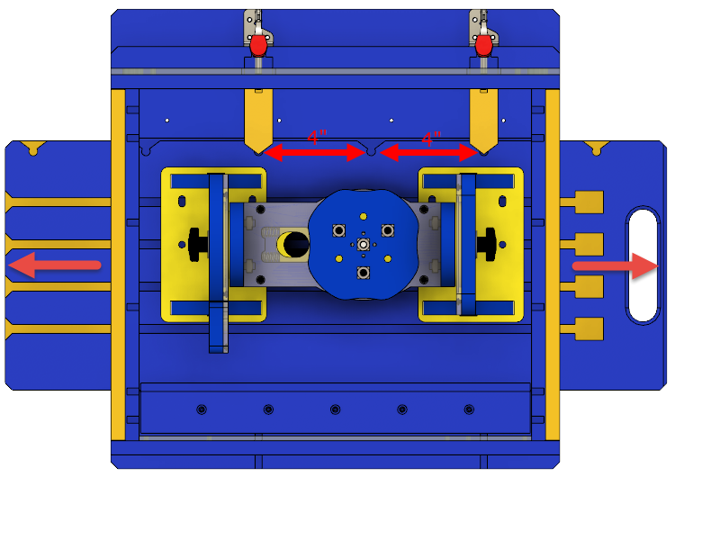Figure

1. Slide the accessory base tray into the accessory base frame. The yellow pins on the frame should be aligned with the V-grooves on the tray (Figure 9).
2. Close the two red toggle clamps to lock the tray in place.

Figure

#### Notes for 4 Axis:

Parts exceeding the 8 inch Y-travel length of the Handibot can be cut by tiling the cut file and indexing the accessory base tray along the tool’s Y-axes.

1. Release the red toggle clamps on the accessory base frame.
2. Slide the accessory base tray in increments of 4” between the V-grooves on the accessory base tray (Figure 9).
3. Engage the toggle clamps in their new position and begin the next cut file in the tiling sequence.

#### Notes for 5 Axis:

If the height of the stock material mounted to the trunnion exceeeds 2.7” it wil be necessary to rotate both the trunnion and mounting plate to a 90 degree position in order to provide enough clearence to initially slide the Accessory Base Tray into the Accessory Base.

The Manual +2 Axis baseplate should be approximately 4.5” from the edge with handle of the Accessory Base Tray (Figure 10). This is to ensure that there is enough room to properly zero the tool (as discussed in the Zeroing section) for 5 axis.

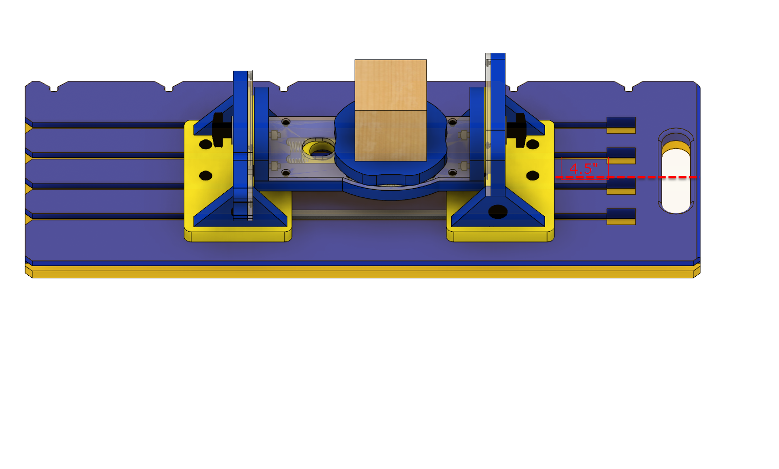

Figure

Material Selection and Setup

4 Axis:

Material geometry is limited to a cylinder of diameter 4 inches (however the Handibot has a Z-travel of only 3.25 inches). Part length should be limited to 8 inches without indexing, and 16 inches if the part does require indexing (Figure 9).

In order to mount stock using wood screws:

1. Install 4 wood screws through the 4 1/8” holes surrounding the center square nut on each of the two mounting plates. NOTE: This is made easier by temporarily fastening the mounting plate through the center hole with a wood screw to drill the surrounding pilot holes (Figure 11)
2. Note exposed screw length embedded in the stock. Do not machine past these Y-limits as contact between the bit and embedded screw will damage the bit.

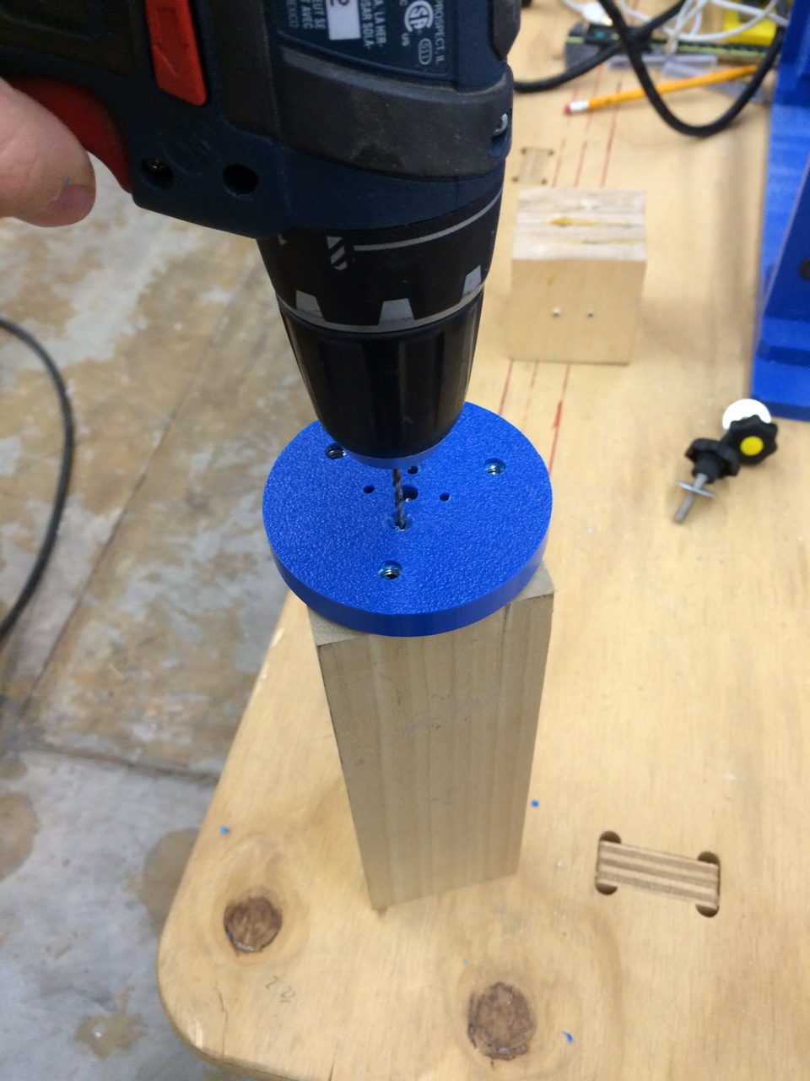 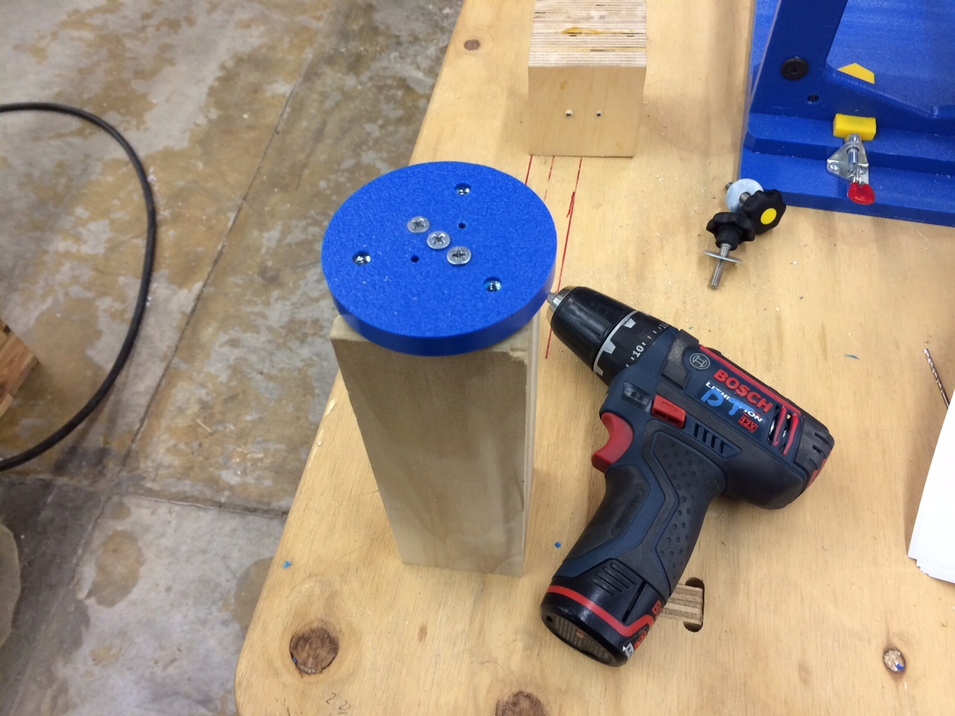

Figure

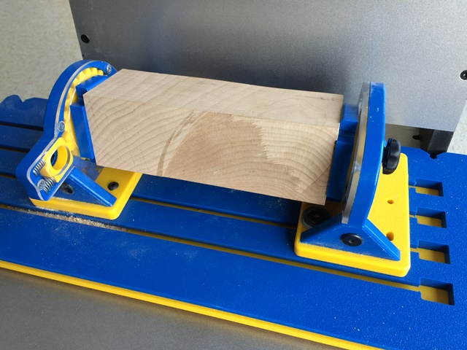The Handibot will be zeroed to the jig itself, and not the stock, so high tolerance positioning of the stock to the mounting plate is not necessary, so long as there is enough stock to account for the part to be machined.

1. Attach the mounting plates (now securely attached to the stock) to both the driving and driven sides using the 6 ¼-20 mounting bolts and center tightening knob (Figure 5).

Figure

5 Axis:

Limit stock size to a cube of dimensions 3x3x3.” In order to mount stock using wood screws:

1. Install 4 wood screws through the 4 1/8” holes surrounding the center square nut on the mounting plate. NOTE: This is made easier by temporarily fastening the mounting plate through the center hole with a wood screw to drill the surrounding pilot holes (Figure 13)
2. Note exposed screw length embedded in the stock. Do not machine deeper than this Z-limits as contact between the bit and a screw will damage the bit.

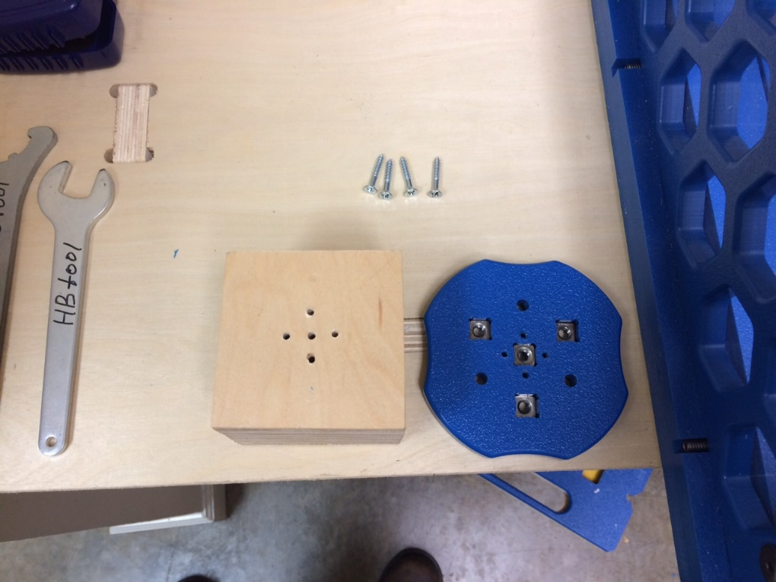 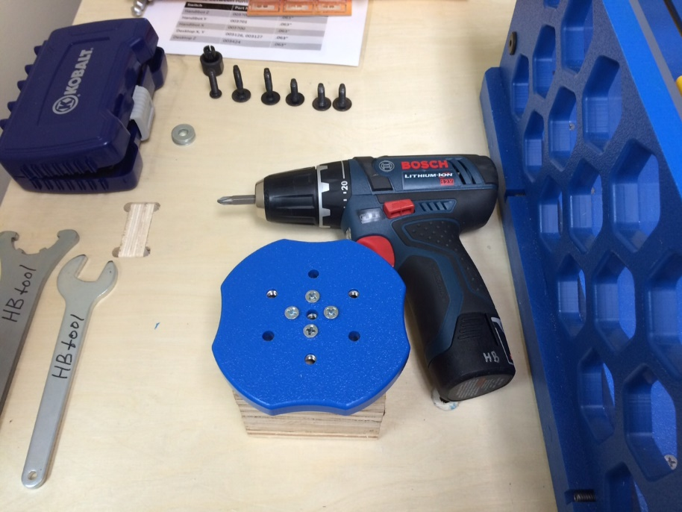

Figure

The Handibot will be zeroed to the jig itself, and not the stock, so high tolerance positioning of the stock to the mounting plate is not necessary, so long as there is enough stock to account for the part to be machined.

1. Attach the mounting plate (now securely attached to the stock) to the trunnion using the 3 ¼-20 mounting bolts and center tightening knob (Figure 4).

Zeroing

When zeroing parts loaded into Manual +2 Accessory, all zeroing should be taken relative to features on the accessory, and not the stock itself. Zeroing to the stock material will result in significant errors in cut files, and will not provide a true representation of how the stock material is being rotated

The zeroing process requires multiple touch-offs and use of the “paper test” as described below. To zero the tool to a surface:

1. Load a dowel or end mill into the Handibot collet and adjust router height by raising or lowering the router in the Handibot’s mounting bracket.
2. With the SB3 software, raise the cutter height above the stock and Manual +2 Axis Jig (whichever is tallest) and execute a C3 command to zero the tool in the X and Y. Any positioning and zeroing of the tool can be recorded and returned to in the event that position is lost. It is very important to record subsequent X and Y zero positions relative to the C3’d tool.
3. Hold a piece of paper between the surface to be zeroed, and a dowel or end mill
4. Approach the surface to be zeroed using the fixed keyboard feature in the SB3 software until the paper can be just barely slid between the two. When zeroing in non-zero axis, the process works best with a dowel however it can also be used with an end mill or other router bits provided that the user rotates the bit so that it always makes contact at its widest diameter. This process is covered in the Handibot User Guide.

Zeroing in the X:

#### 4 and 5 Axis:

1. From a C3’d position, touch off on both sides of the driven side, at or below the red arrows using the paper test and record the two positions (Figure 14).
2. Average the two X values to obtain the true X position of the accessory’s center along line 1. This process is best done with a dowel in place of a router bit.

#### 

Figure

Zeroing in the Y

#### 4 Axis:

1. Touch off on the two mounting plates as shown by the two red arrows (Figure 15). If stock is larger than mounting plates, touch off on outsides of stock.
2. Average the two Y values to obtain the true Y position of the stock material’s center. The Y plane will be parallel with line 1 which is the midpoint between both mounting plates, and thus the center of the stock. As each piece of stock is different, it is critical that both points are taken and averaged. This process is best done with a dowel in place of a router bit.

#### 

Figure

#### 5 Axis:

1. Touch off on the two trunnion arms as per the two red arrows (Figure 16).
2. The center of the 5th axis of the trunnion is offset 0.75” from the center of the trunnion, therefore it is 2.75” from the near trunnion arm, and 4.25” from the far trunnion arm. By averaging the two touch-off points, the Y plane will be parallel with line 1 which is the midpoint between both trunnion arms, and by offsetting by 0.75” the Y plane will be parallel with line 2, which is the true center of the stock. This process is best done with a dowel in place of a bit.

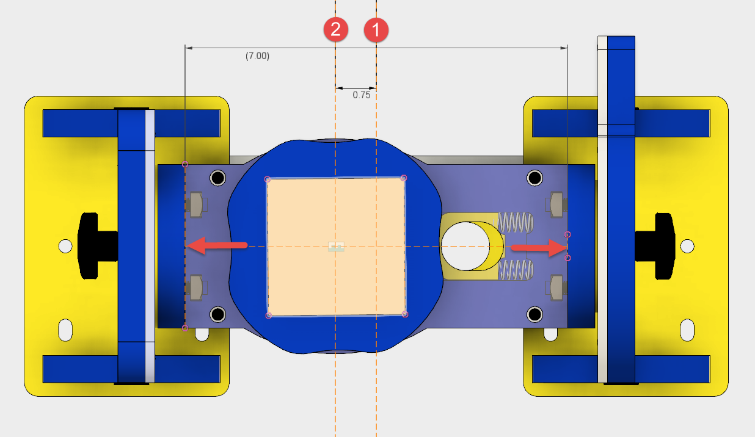

Figure

Zeroing in the Z:

#### 4 Axis:

1. Touch off to the top of the driven side (red arrow) with the paper test, and offset 1.75” to the mounting plate at line 1 (Figure 17)
2. Offset the tool by the desired material thickness and zero location as specified in the toolpath. This process must be done with router bit.

#### 

Figure

#### 5 Axis:

1. Touch off to the top of the driven side (red arrow) with the paper test, and offset 2.02” down to the mounting plate at line 1 (Figure 18). The tool can then be offset again by the material thickness and zero location as specified in the toolpath. This must be done with the router bit.
2. Offset the tool by the desired material thickness and zero location as specified in the toolpath. This process must be done with router bit

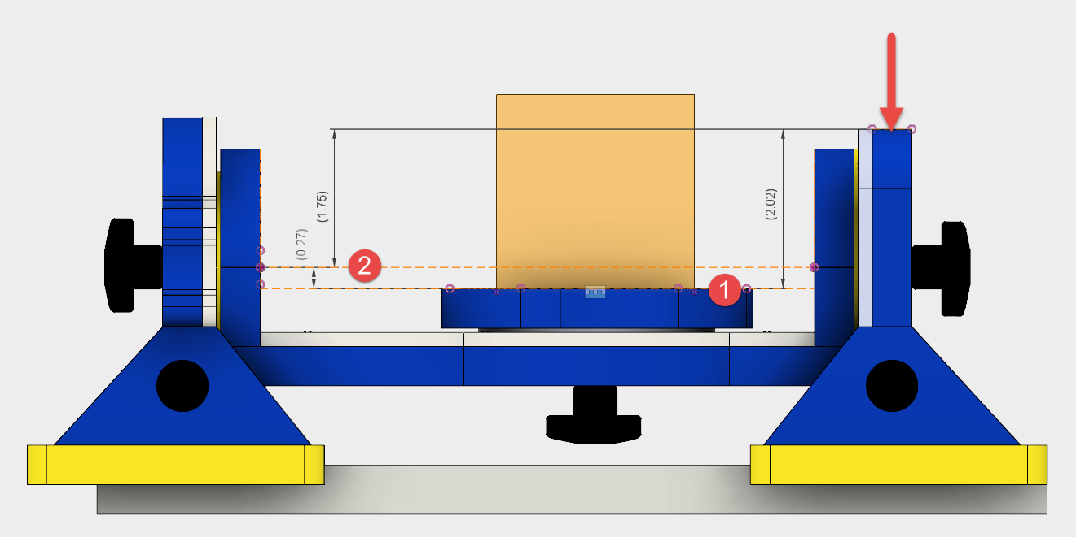

Figure

Desktop and MAX Use

Although this accessory was designed for use with a Handibot and Accessory Base, it can also be used with a larger tool such as a Desktop or Desktop Max. The Desktop or Desktop Max’s spoil board can be removed by unscrewing the 8 recessed bolts in the spoil board using a 4mm hex wrench and setting aside for later use. Sheet materials that would be mounted to the spoil board cannot be cut while the accessory is attached and spoil board is removed.

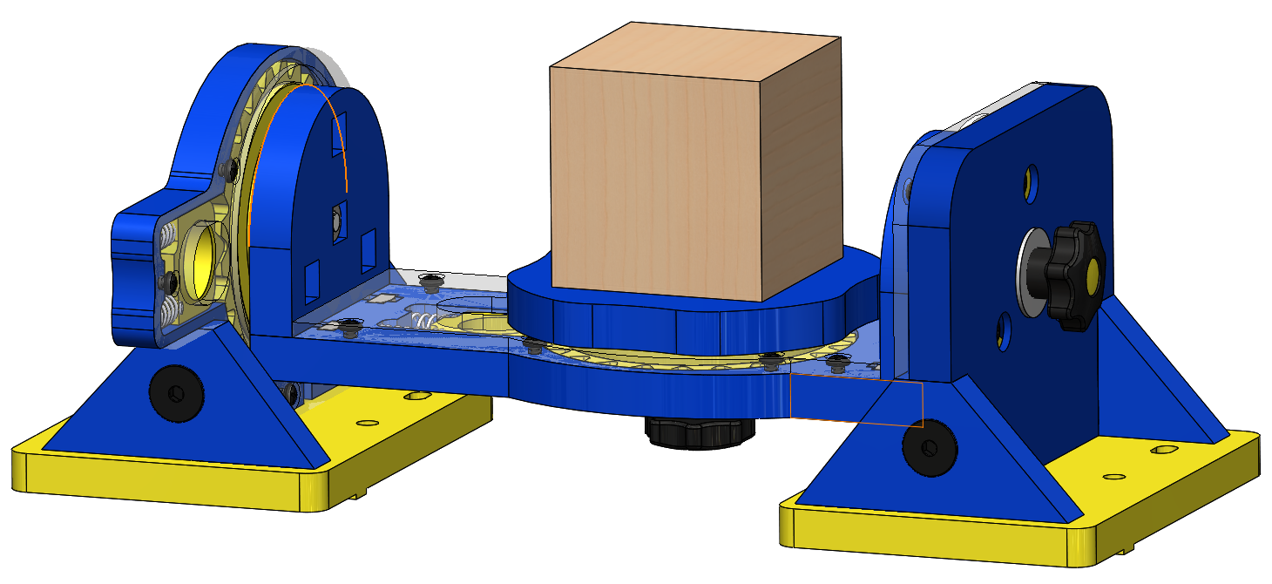The accessory can be mounted to the tool’s aluminum extrusion and used normally in a 4 Axis configuration, as per the Handibot instructions above. NOTE: The extrusion on a desktop is mounted perpendicular to that of a Handibot, so any references to the X and Y axis relative to the accessory will be reversed.

#### 5 Axis Use:

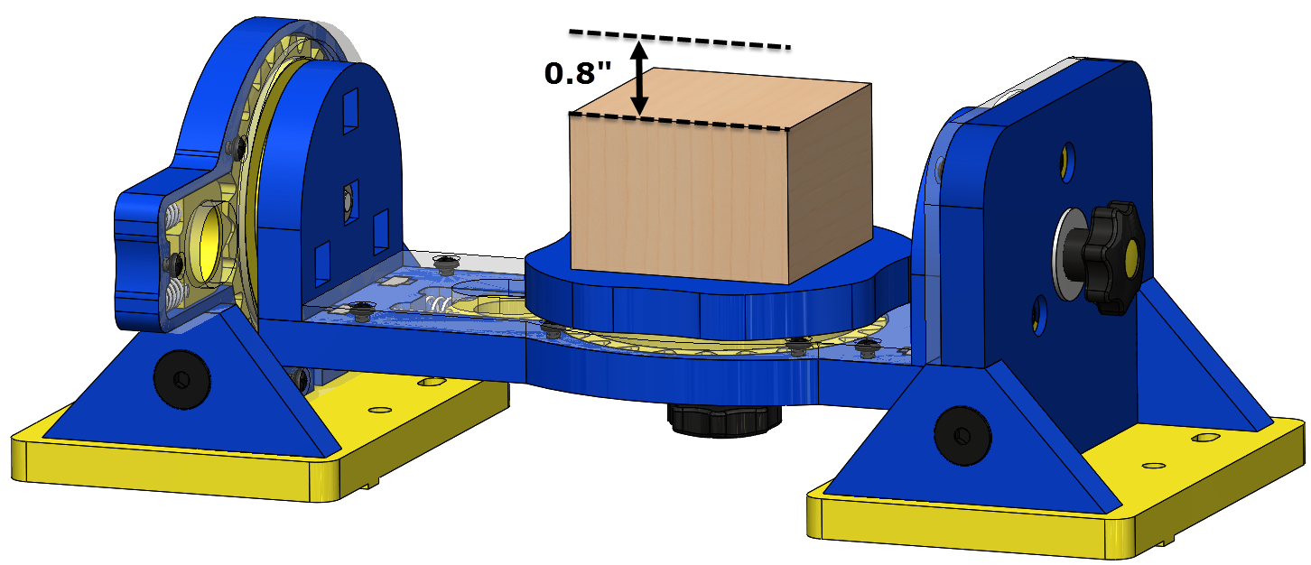Unlike a Handibot, the Desktop tool’s spindle is mounted at a fixed position to the Z carriage and cannot be simply adjusted. The maximum exposed bit length recommended for use with the 5 axis tool when using a 3” height stock is 1.1” (taking into account for a safe z clearance of 0.1”).

Due to this fact, when using the tool in 5 axis, it is not possible to use the full 1.9” length of the 1/8” tapered ball nose bit (13636), which is often practical for the type of carving done with this accessory. Figure 19 illustrates the effect of this limitation.

Figure

Software Use:

Aspire offers a quick and easy way for users familiar with the software to get cutting immediately with their Manual +2 Axis Accessory. However Fusion 360 will provide a stronger set of tools with integrated CAD/CAM and 3 +2 Axis machining. Keep an eye on Fusion 360 developments at:

Aspire Parameters:

The following are useful parameters to keep track of and understand when using aspire to set up a file in either 4 or 5 axis. It is strongly recommend that first time users run their toolapaths at approxiamtely 1/10th of the normal speed to ensure that their cuts are acting predictably and as intended.

**Material Setup Menu (when toolpathing):**

1. ________ - Gap above material
2. ________ - Gap below material
3. ________ - Home/Safe Z Height

**Additional Considerations:**

* Z Zero Position
* XY Datum Position
* Zero Plane Position in Model
* Exposed screw length

**Job Setup Menu:**

1. ________ - Material X dimension
2. ________ - Material Y dimension
3. ________ - Material Z dimension

**Orient 3D Model Menu (when importing a 3D file):**

1. ________ - Model X dimension
2. ________ - Model Y dimension
3. ________ - Model Z dimension

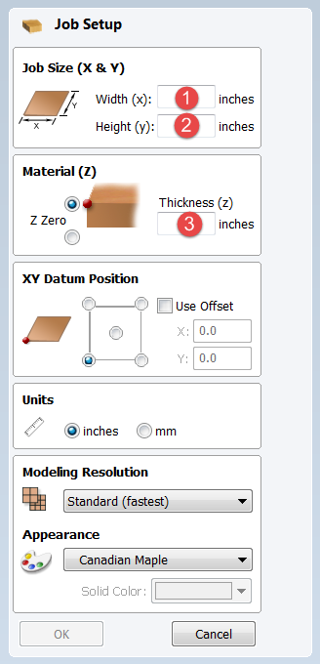 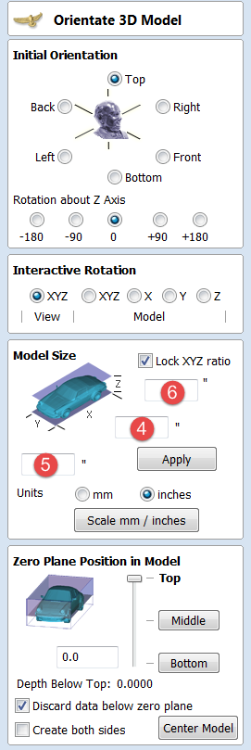 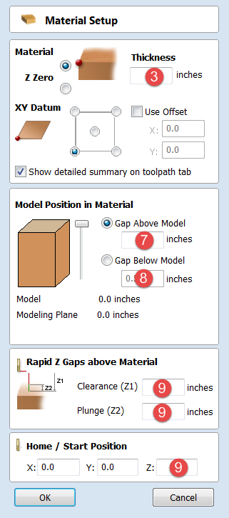

Figure

Aspire 5 Axis Rotation:

For parts machined in 5 axis with non-90 degree rotations it is recommended that an integrated CAD/CAM package is used such as Fusion 360. Aspire does not support interactive rotation of parts by fixed angular intervals, therefore in order to machine at non-90 degree intervals, it would be necessary to orient the part in external CAD software such as Fusion 360, and then import it in the desired position.

When rotating the trunnion axes at 90 degree intervals, the stock will be offset in the X and will have to be repositioned in order to zero the tool to the center of the stock. This is because the center of the axes of rotation of the trunnion is not collinear with the axes of rotation of the stock. For a 90 degree rotation, the X offset caused by the rotation of the trunnion can be accounted for by taking:

$$\frac{Material X Dimension}{2}-\left(0.27+\frac{\left(Material X Dimension\right)-\left(Material Z Dimension\right)}{2}\right)$$

The 0.27” is a constant defined by the geometry of the accessory, specifically the distance between the center of rotation of the trunnion, and the mounting jig (Figure 18).

ShopBot Tools, Inc. Technical Support

3333-B Industrial Drive, Durham NC 27704

support@shopbottools.com

1-888-680-4466